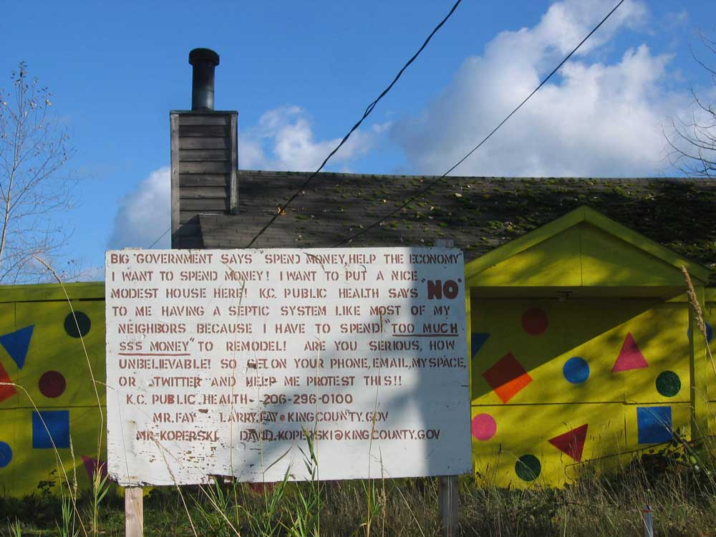

The Little Yellow Polka Dot House v. The Municipality CON Man

http://artists.letssingit.com/cgi-exe/am.cgi?a=artists_video&song_id=wzxlmlw

No covenants, restrictions or contracts were ever owner agreed to be bound
In these fictional commercial British corporate municipalities
Self serving councils long forgot the higher founding and fundamental grounds
Private property or wages cannot be taxed, regulated or taken down

Codes invented by the green and yellow municipality council of CONs
Our natural waste became an unnatural crime for revenue
What all animals freely do upon the ground
The Natural Born, their property and septic systems are confiscated too, by the municipals

One by one each private property abode grows old and is closed down
By illegitimate misapplied commercial permits, taxes and plans
The British Kings and Queens invented this corporate municipal CON
They codified and criminalized the natural rights and natural habits of man

Weather, fuel and rural living too, were coded into crimes against humanity
Little houses that always survive in natural cycles of wet and dry
Where water tables naturally rise and fall
The yellow municipality coded this for their revenue and stole it all

The high priests of the global elite associations and municipalities
Revoked the great American Founding and Fundamental Laws
Declared a continual national state of Emergency and Revocation
To collect more revenue by legal fictional commercial laws

The first American Revolution rose up and rearranged
The Rights of man and gave him allodial rights upon his land
But ONLY the names of the British Kings and Queens changed
Individual freedom never came

Against all odds, little houses grew across the land
Great and small in their natural uniqueness and multiplicity
But ownership was systematically taken down by the new King’s and Queen’s greedy hands
They conscripted our property, media and land into artificial commercial municipalities

No freedom, no liberty, no property, no life ……no private or public use of OUR land
Only dirty revenue to pay the despicable debt of the municipal CON
Paid for by the extorted, untouchable wages and property of the Natural Born working hands
And generations of blood and tears continue to spill upon our own land

British municipalities go against all founding and fundamental laws
The Natural Born Sons and Daughters were conned
By the parasitic Associations, Mayors, Councils, Benches and Bankers
In and around these towns

The Second American Revolution & militia silently sprouted up in these communities
They organized against these green and yellow municipality towns
Urban and rural property owners rose up and fought against over two centuries of feudal takings
Another American Revolution brought the British American monarchy down

One third of the population sold out to the kings and queens municipalities
One third waffled to wherever there was greed
One third to one half said they wanted to be free
Only two thirds of one percent actually marched against the King’s municipalities

Jack Venrick
Enumclaw, Washington
www.FreedomForAllSeasons.org

